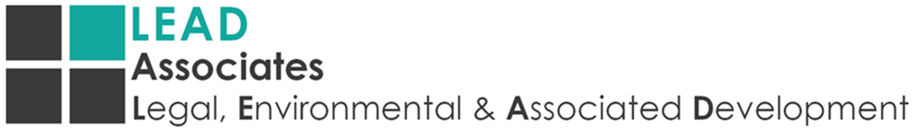

Safety, Health and Environmental Policy
The management of LEAD ASSOCIATES, striving for excellence in all we do, recognises the impact that our activities may have on people and the environment.
LEAD ASSOCIATES is comprised of an experienced and qualified project team which is backed by the expertise offered within the rest of its vast portfolio, and exceeds a combined 40 years experience in project management. Our focus is implementing environmental programmes and projects which have the potential to grow individuals within the green circular economy.
To implement and maintain, as far as is reasonably practicable, the activities of the company in such a manner, as to prevent harm or damage to persons and property respectfully.
Safety, health and protection of the environment will form an integral part of our planning and decision making. We will manage our company, wherever we do business, in an ethical way that strikes an appropriate and well reasoned balance between economic, social and environmental needs.
We are committed to:
- Conducting our business with respect and care for people and the environment
- Responsible utilisation of natural resources
- Continually improving our safety, health and environmental performance
- Complying, as a minimum, with all applicable legal and other agreed requirements
- Promoting dialogue with stakeholders about safety, health and environmental performance
We will achieve these by:
- Implementing safety, health, environmental management system
- Informing and appropriately training all employees and contractors on safety, health and environmental matters
- Responding effectively to safety, health and environmental emergencies involving our actives and products
- As far as reasonably practicable, providing appropriate resources required to implement the above
- Ensure that the health, safety and environmental policy is reviewed at periods not exceeding three years from the effective date or by a date set by the Chief Executive Officer.

. .
Chief Executive Officer Date

